Admin Panel User Manual

SITE URL: <http://secnepal.defttree.com/>

ADMIN URL: <http://secnepal.defttree.com/login>

*Note: URL will be changed whenever hosting is changed*

# Accessing Admin Panel

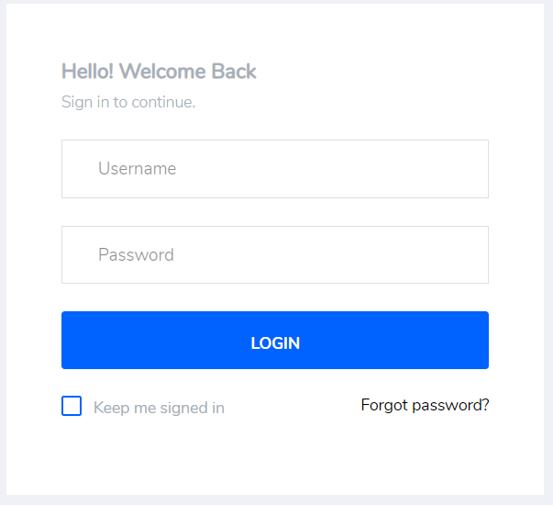

Username: superadmin

Password: password

*Note: username and password will be changed as per necessity.*

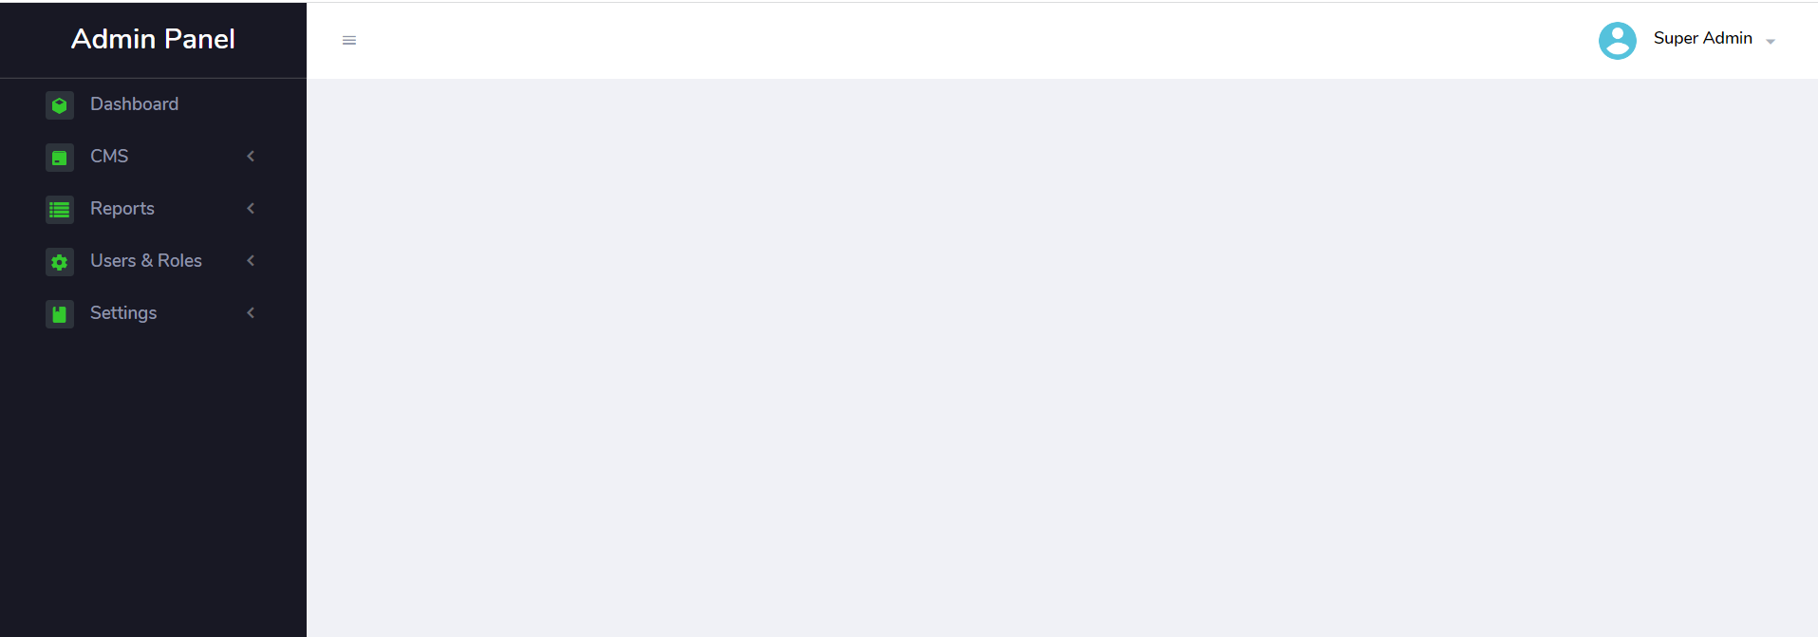

After Login you will land to dashboard page, as shown in above picture.

# Understanding Action ICONS/Buttons

|  |  |  |
| --- | --- | --- |
| ICONS/BUTTONS | Title | Description |
|  | Add New | To create a new record user needs to click this button. It will help users to open an entry form. |
|  | Edit Record Icon | Allows user to redirect to edit form. |
|  | Delete Icon | Helps user to delete unnecessary records |
|  | Status / Featured | Show the current status of record. It Also allow to change the status from active to inactive or vice-versa. It act as same for featured action. |
|  | Sequence input | Help user to set display order in website. |
|  | Search button | Helps to filter the record in the list. |
|  | Sorting Icon | Allows user to sort the record. |
|  | Admin Side Menu | It contents the site for admin panel. Through which admin user can setup the website content. |

# Setting up the website / Site Settings

At first we need to setup basic parameters for website. Like its name, logo, contact information and more. To setup the basic parameters first go-to settings from admin side menu. Then click on Site Setting. A setting form will appear to admin user as shown in below picture:

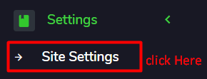

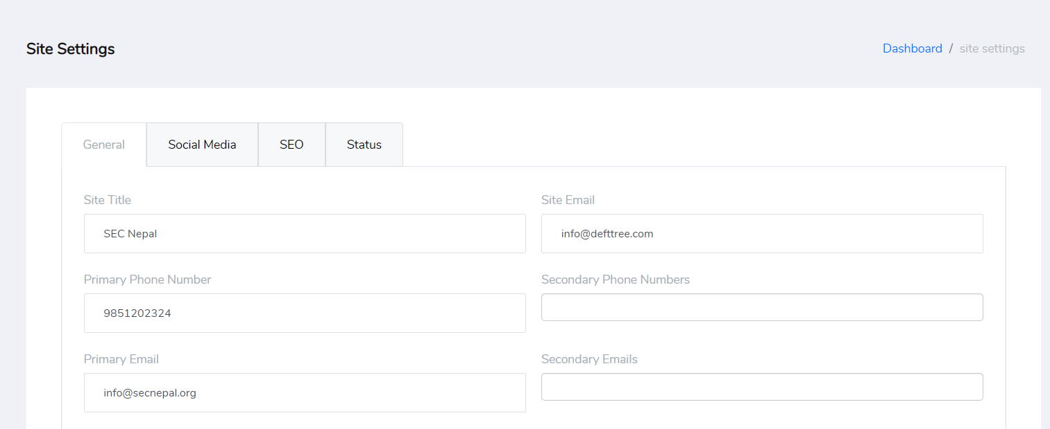

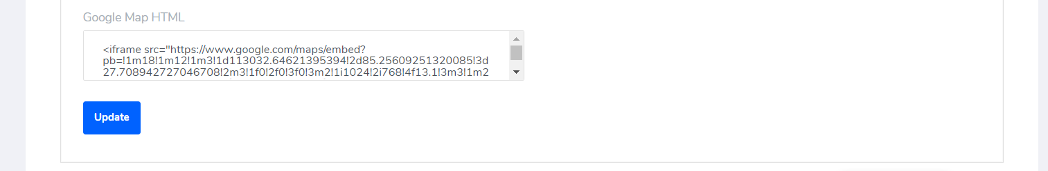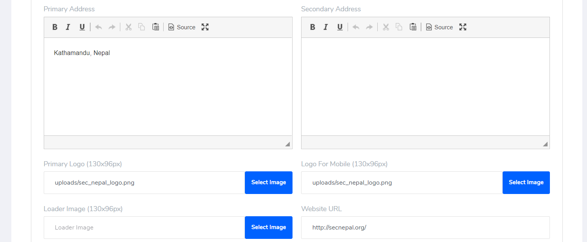

There are four tabs in this setting page.

1. General
2. Social Media
3. SEO
4. STATUS

Fill all the necessary information in tabs and click on update button. Tab information are given below:

## GENERAL TAB

* Enter the site name or company name for which website is developed.
* Enter site email this email must be valid email as it will be used in email circulation through website.
* Primary Phone and Email: This phone number and email will be displayed in website in top header, footer and contact us page.
* Secondary Phone and Email: This will be displayed in contact us page only. User can enter multiple phone numbers and emails. Just separate it by **comma “,”.**
* Primary/Secondary Address: Enter the primary location detail of company. Primary address is displayed in website. No need to setup secondary address.
* Primary and Mobile Logo: Select the both logos. Primary logo will be displayed when user browse through laptop or desktop. Mobile logo will be displayed only on mobile or smaller devices.
* Loader Image: Select the loader image to be display while loading the website. Default loader is shown below:



* Google Map HTML: Enter the sharable html from Google map.
  + First visit Google Map through browser.
  + Search for desired location.
  + After search you will notice on left panel there is share button. Click Share button.

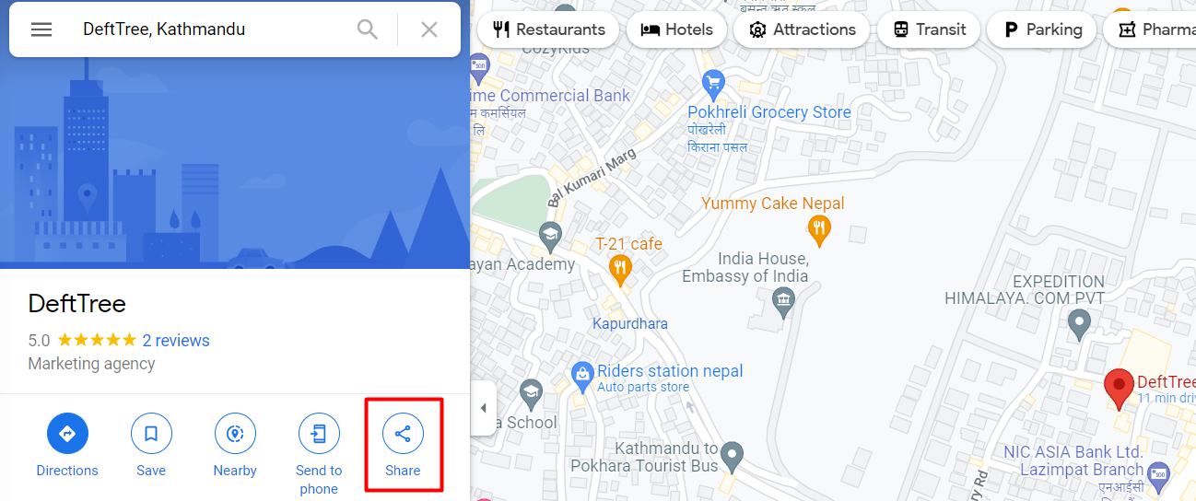

* + 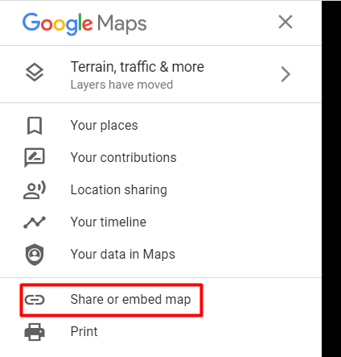If you didn’t file share button then click the icon as shown in below picture. Now click **share or embed map**

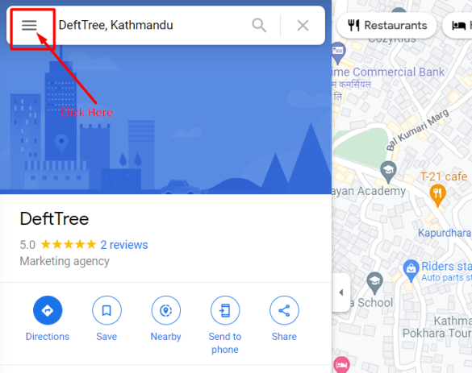

* + You will get a popup window as shown in below picture and click **Embed a map and COPY HTML**

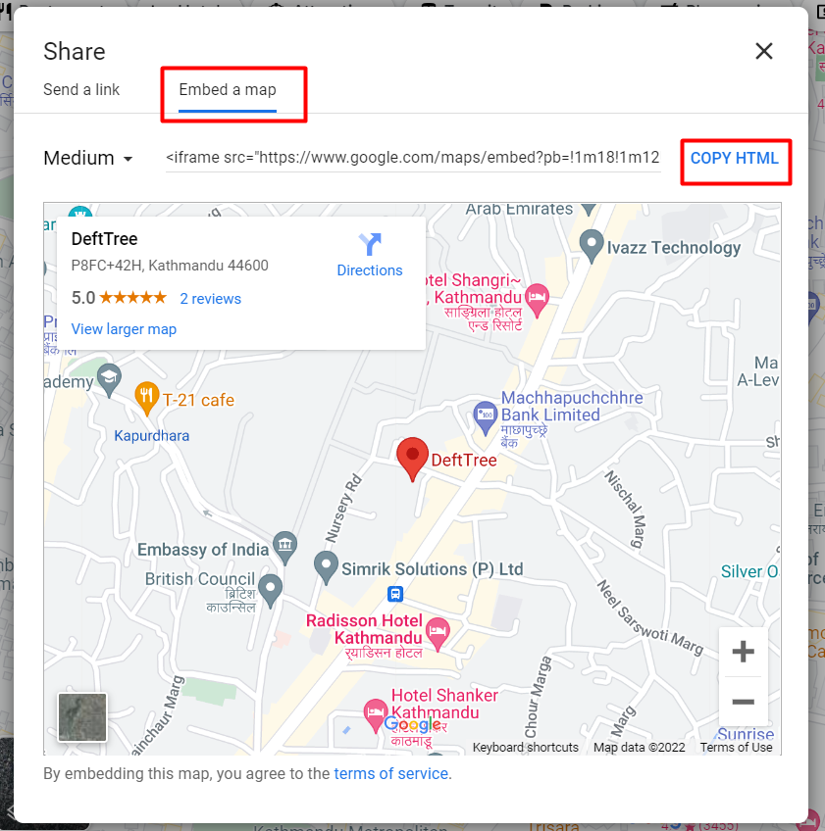

* + Now paste to notepad and change the height to 450 and width to 100% as shown below:



* + Copy the all text and paste it to Site Setting Google Map HTML.

## SOCIAL MEDIA TAB

* Enter all available social media links like Facebook page, twitter, LinkedIn, Pinterest, Youtube channel link and Instagram link.
* For Viber enter Viber number.
* For skype enter skype username.
* Enter facebook page ID to enable facebook messenger in website.

## SEO TAB

SEO is used to optimize your site in search engine. This tab allows users to set default site SEO parameters.

* META TITLE: This title is shown as search engine title and also is displayed in browser tab. Enter your search keyword over here.
* META DESCRIPTION: This is used to display short description while searching through search engine.

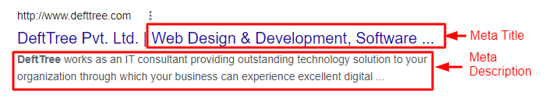

* To share additional information in social media like Facebook and Twitter enter title, description and image to be shared.

## Status TAB

If admin wants website to be offline set status as offline and write some messages in offline message section.

*\*After filling all necessary information click update button.*

# Home Setting

Home page is the landing page for website. So this page need to be setup very carefully. Below are the steps to setup home page.

* Go to site setting in admin panel side menu.
* Click on Home setting.
* A setting form will open.
* Fill the page and click on submit.
* It content section wise tab.

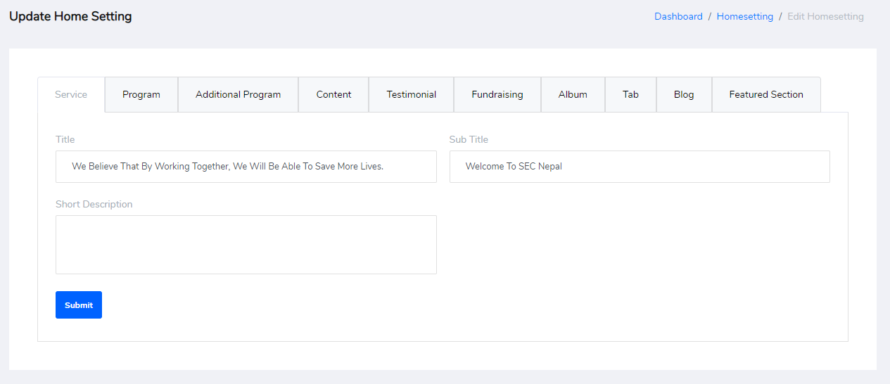

* Slider will be setup through banner management. Please check tutorials below.
* Other section setup information are given below:

## Service TAB

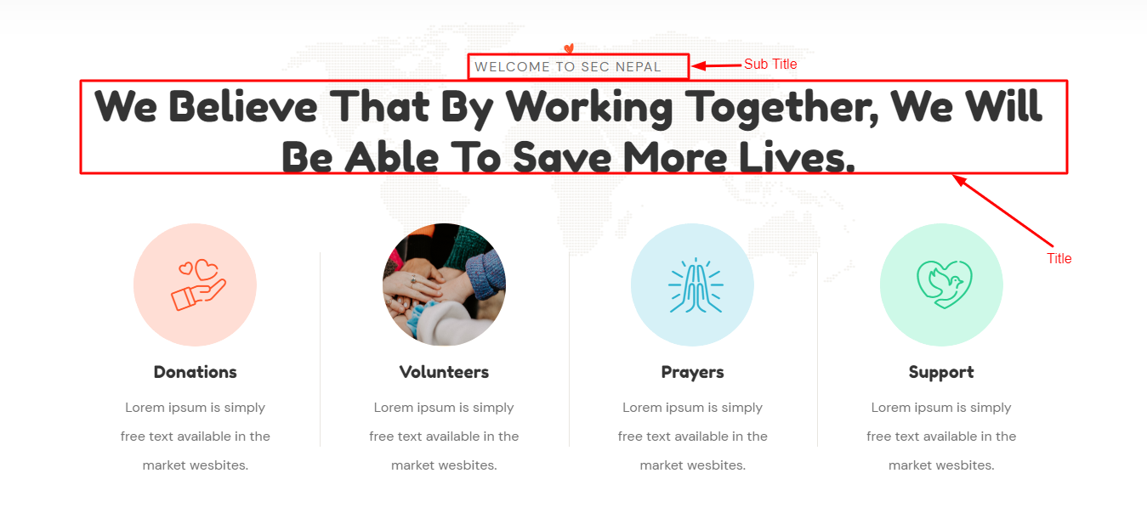

* Enter title and sub title for this section.
* Other topic will come through service management. Please check the tutorial below.

## Program TAB

* Similar as service, in program tab also please enter title and subtitle. Program detail will be setup through program management. Please check tutorials below. This will be displayed in website as given below:

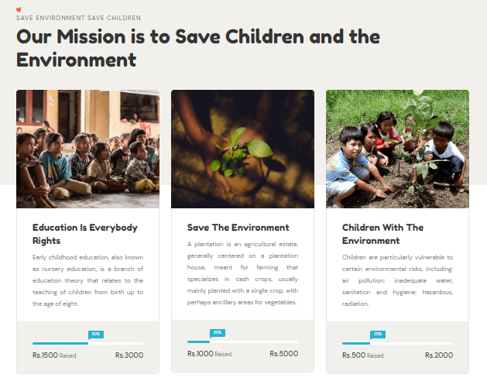

## Additional Program TAB



This tab allows to display above picture section in home page. After adding program, if administrator wants to focus on some program than select the program (at least two) from the list of programs shown in this tab.

## Content TAB



Select the single content that you want to display in this section.

## Testimonial

In this tab title and subtitle for testimonial section is setup. This section display what customer/client has to say about the company. Admin can add the content through testimonial management.

## Album TAB

This tab allows admin user to show some selected album list in home page. For this just select around four albums from the list.

## Fundraising TAB



This is an additional banner in home page design to focus fundraising campaign.

* Enter the title and subtitle for this section.
* Enter button title
* Enter the URL to be redirected on button click.
* Select the image from media manger

## Tab TAB

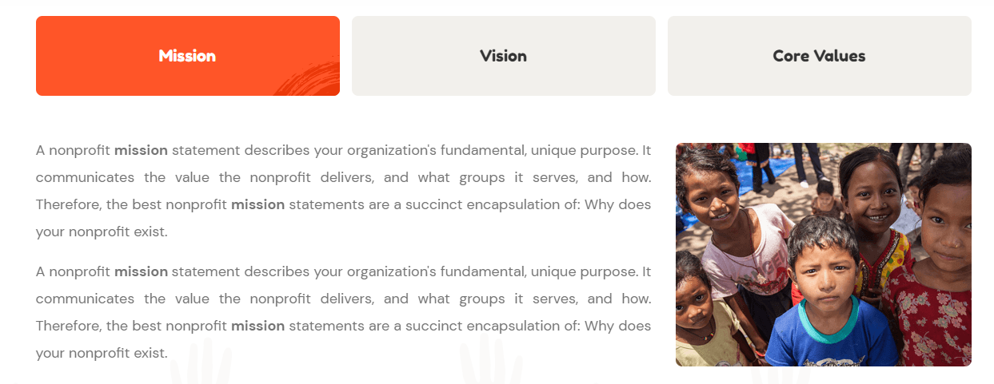

This section is setup through this tab. Just select the content for each tab and update the setting.

## BLOG TAB

This tab setup the title and subtitle for blog section in home page. Blog list will be displayed through blog management. Only featured blog will be shown in home page. Other blog will be listed in blog page.

## Featured TAB

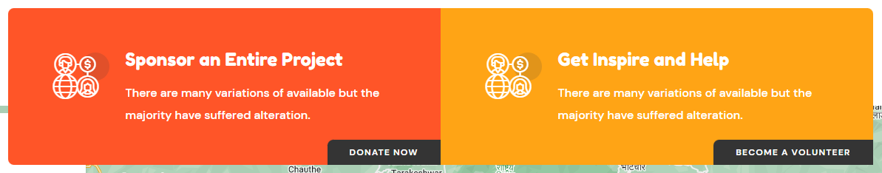

This section allows admin user to show additional information in website home page. Fill the form displayed in this section and click on submit button.

# Counter Setting

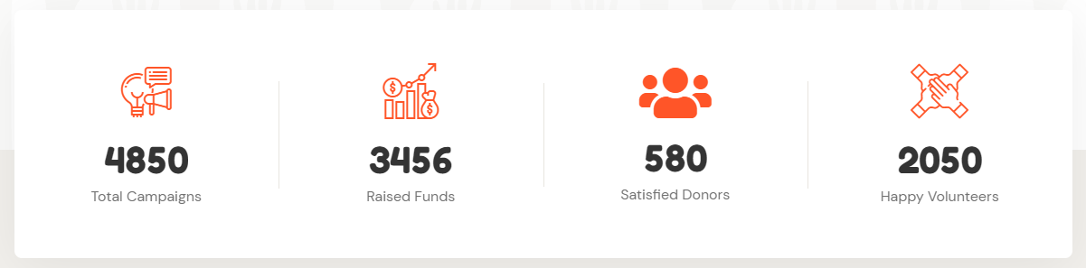

This counter setting is displayed in home page. Please follow below steps to setup counters:

* Goto setting in admin panel side menu.
* Click to counter setting
* A page to show list of counters will appear.
* Click to Add New button.
* A form will open to add counter information.

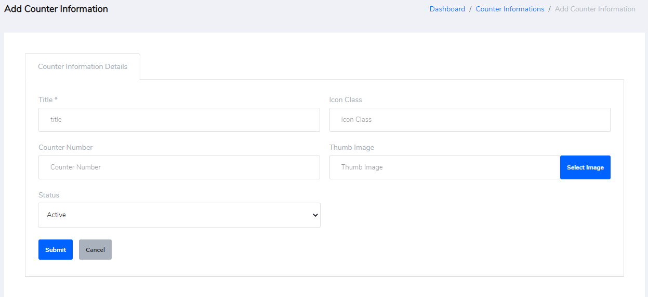

* Enter the necessary information and click on submit.
* Add at-least four information in this section.

# Introduction/About Page Setting

This page is not a home page. This is separate page to display company information like introduction or something meaningful. To setup this page please follow the below steps:

1. Choose Setting from admin panel side menu.
2. Click on Introduction setting.
3. A setting form will open. Please provide the information to display in website.
   1. Provide title, sub title, description and image in content section
   2. Similar to home setting select the content for tab view.
   3. Provide the necessary information for second banner section.
   4. Provide title and sub title/tagline for volunteers and testimonials.
   5. Choose the option to enable or disable supports/testimonials/volunteers’ section in the page.
   6. Now click on submit to update the setting.

# SMTP Setting

SMTP setting is done to circulate email through website. This is one time setting i.e., once this setting is done no need to change it until it necessary. Basic setup explanation has been given below:

* Go to Site Setting from admin panel side menu.
* Click on SMTP setting
* Provide Hostname: Hostname of your email address.
* Port Number: Enter the port number for SMTP.
* Authentication: Choose authentication required or not. If you want mail to be circulated through SMTP than choose yes otherwise choose no.
* Encryption: Choose encryption type as SSL or TSL for SMTP mailing.
* Username and Password: Provide the email address and its password through which email will be sent.

# Payment Setting

Payment setting is done in order to receive payment through different method. Currently, there are three methods included in this system:

1. ESEWA
2. PAYPAL
3. BANK TRANSFER / Offline Method

Through this setting ESEWA and PAYPAL set up is done.

1. ESEWA:
   1. To setup this method first you need to have merchant account In ESEWA.
   2. After opening merchant account with ESEWA, it provide you a merchant code.
   3. Type the code provided by ESEWA and save the setting.
2. PayPal:
   1. To apply this method you need to have business account with PayPal.
   2. Once business account is opened than PayPal allows you to setup donation button.
   3. Setup the donation button.
   4. Copy the html part of donation button provided by PayPal and paste it to PayPal Tab of payment setting.
   5. Now save the setting.
3. Bank Transfer / Offline Method.
   1. Goto Site Settings from admin pane side menu.
   2. Click on Bank Information.
   3. A listing page will appear.
   4. Now click on add new button at top of page.
   5. A new form will appear for setup.
   6. Provide the title for offline method.
   7. Provide the detail information.
   8. Save the setting.

# Email Templates

This setting allows user to setup the email messages that needs to be sent to customer. Developer will setup the basic setup for this template whereas admin user of website can modify the messages setup by the developers. Below are the brief description of email templates:

* Go to Site Settings from admin panel side menu.
* Choose Email Templates.
* List of available email templates will appear.
* Click on add new button. A new form will appear in front of user.
  + Template Name: This parameter is setup by the website developer. Don’t change the name of template. Do notify the developer after changing its name.
  + Select Admin User: This parameter allows admin user to select multiple admin user for which selected email templates need to be circulated as email.
  + Custom Emails: If admin user want this template to be sent to additional person than provide the email address over here. Multiple emails can be provided which needs to be separated by **comma “,”.**
  + Admin Subject: Subject that need to be sent to admin users. This can be changed.
  + Admin Message: Message that needs to be sent to admin users. In this message some parameters will be setup by the developers between symbol **{{**parameter**}}**, don’t change this text, other text can be changed. For example, check the below picture, the text marked with red box contents **{{message}}, {{site_title}},{{site_link}},** admin user should not change this parameters. Other text or message can be changed easily.
  + User subject can be changed. This will be send to website visitor.
  + User Message this is similar to admin message. This message will be sent to customer/ website visitor.
  + Make the change and save the change.
  + 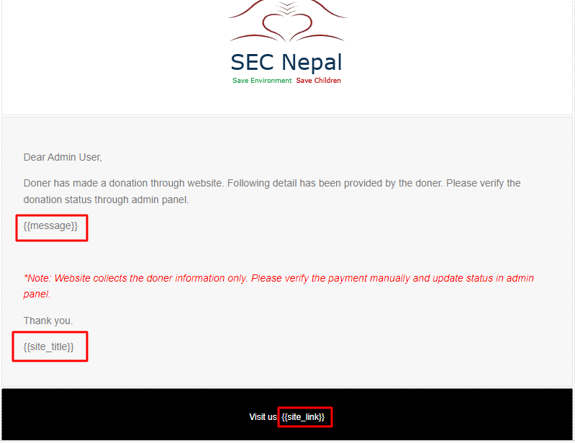

# Internal Links

This part is also setup by the website developers. So the admin user is recommended to edit the detail provided by the developer.

* Go to site settings
* Choose internal links.
* A list of internal links will be listed.
* Click on edit button.
* A form will appear with previously entered details.
* Just make the necessary changes and save the setting.
* Please don’t change the slug of any record.

# Listing page

Listing page is the main page of every management page. When admin user clicks to side menu of admin panel most of pages will be landed on their respective listing page. This page shows the list of records added in database. This page allows admin user to perform other actions like add, edit, delete, filter and sort the records. Most of the management pages are inside CMS of admin panel side menu. Below picture show the listing page and its sections:

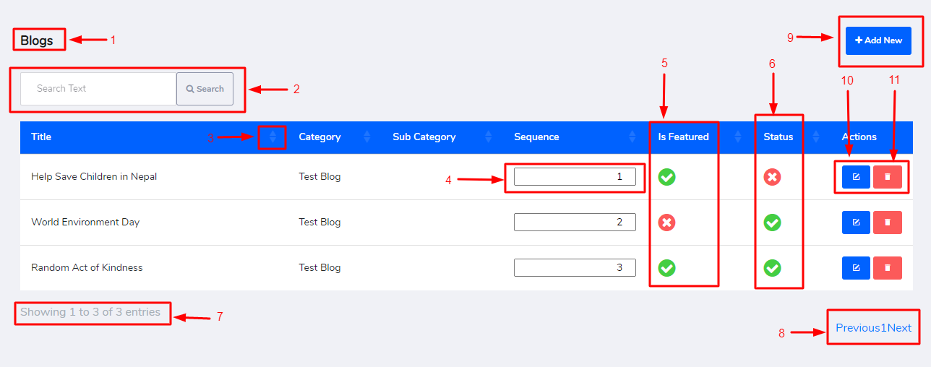

1. **Page Title:**
2. Show the title of the management page. Example: Blogs, Programs, Events and more.
3. **Filter:** This feature allows user to filter record by any text. Enter the text and click search button.
4. **Sorting records:** With each heading of records there is a sorting icon. Click the sorting icon to sort the data in ascending or descending order.
5. **Record sequence:** Record sequence feature allows user to change the display order in website. It doesn’t create any effect in the management page but display order in frontend of website is changed.
6. **Is featured:** If record is marked as featured than this will be visible in-home page. Green icon for featured and red icon for not featured. Admin user need to click on each icon to change its state.
7. **Status:** A record will have two status as Active or Inactive. Active records are shown in website where are inactive record are not visible in website. Admin user can change the status of record by clicking the status icon. Green icon is for active status and red icon is for inactive status.
8. **Paging Detail:** Paging detail shows the total number of records in database and total no of records displayed in current page.
9. **Pagination:** Out of total records only 100 records are displayed the list. Rest of the record will be displayed in another page. So, this feature allows admin user to switch the record from one page to another page.
10. **Add New Button:** This button will redirect to add page where admin user can create a new record.
11. **Edit Button:** Edit button allows user to redirect to edit page.
12. **Delete Button:** Delete button allows admin user to delete the record from the list. Admin user can delete the unnecessary records by clicking the delete icon.

# Add Page

This page allows admin user to create a new record. To add new record click on Add new icon in listing page. User will be redirected to add form as shown in picture below:

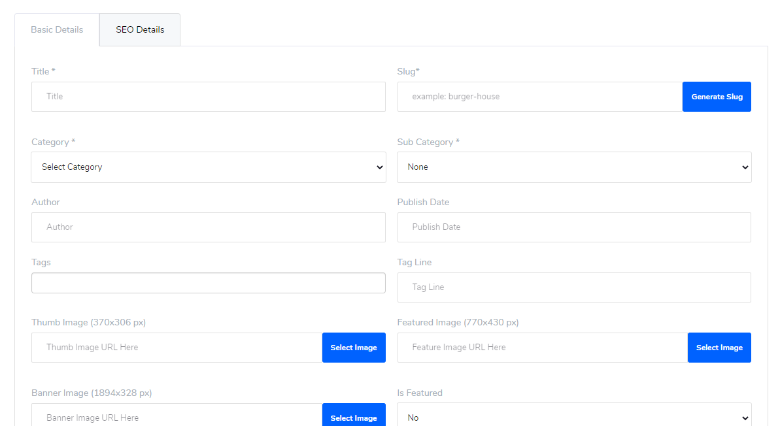

* Fill the form with necessary information.
* All * marked field are mandatory.
* Choose category at first than only select sub category.
* Select the necessary images from the media manager.
* Provide the SEO detail for the page.
* Save the information to create a new record.

## Type of images for website

Thumb Image: Thumb image are the images that are displayed in listing pages. The recommended size of thumb image is **370 x 306px.** It will be displayed in website as shown in picture below:

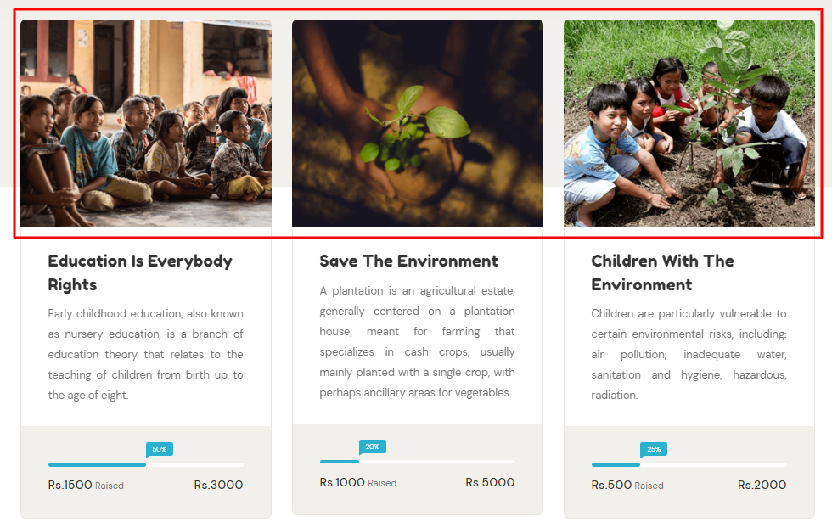

Thum Images

**Featured Image:** Featured image are displayed in detail page of record. The recommended size of featured image is 770 x 430px. Below picture show how featured image are displayed:

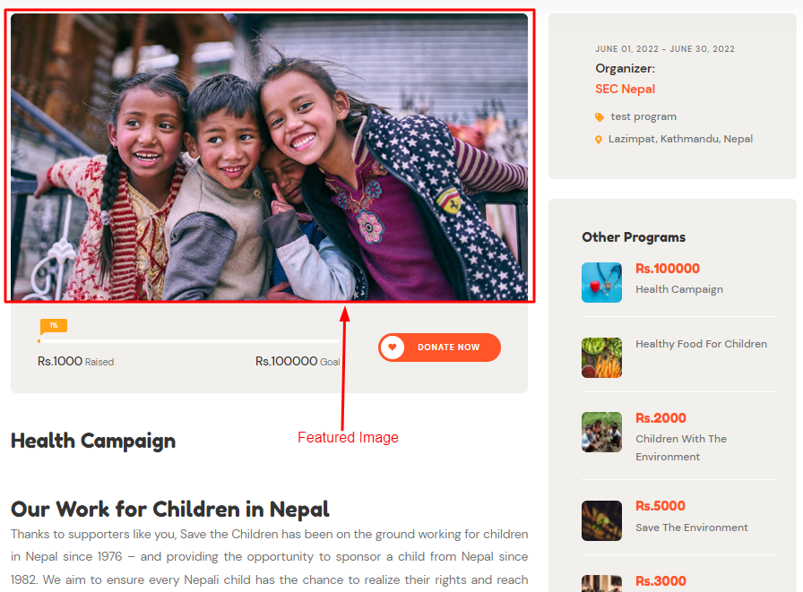

**Banner Image:** Banner images are also displayed in detail page of record. The recommended size for banner image is **1894 x 328px.** Display location of banner image in website is shown below:



# Editing Record:

There might be mistake while creating a record. So, this featured allows admin user to correct the mistake with updated data. To edit the record click on edit icon of selected record. User will be redirected to edit form. Make the necessary changes and click on save button.

# Delete Record

This feature allows admin user to delete the unnecessary record from the list. Click the delete icon of respective record. A confirmation popup will appear to user as shown in picture below:

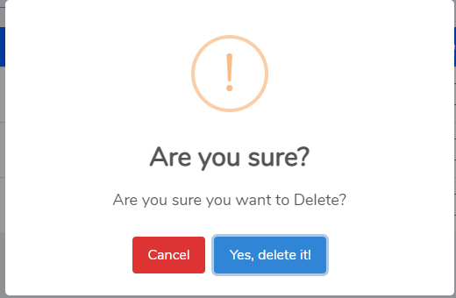

Click **Yes, Delete it!** Button to delete the record permanently from the list.

# Content Management System (CMS)

## Category and sub-category

Allows user to categorize the records. Create the necessary category and its sub category.

## Banner

Banner allows to set slider information in website. Record added through banner management will be displayed in website slider.

Title: Enter the title for the banner.

Subtitle/Tagline: Provide the tagline for banner if necessary.

Image: Select the image from media manager.

Video URL: Copy the video link from source and paste it in Video URL field.

Primary Button Title and URL: Provide the primary button title and URL.

Display of banner in website is shown in picture below:

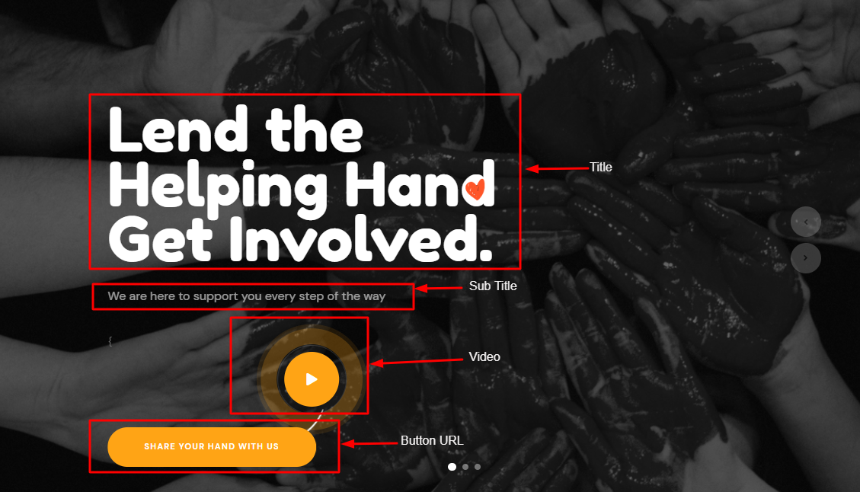

# Pages

This management will allow user to create new pages in website. Add the page and link it through site menu. Page management is also known as content in different setting sections. Below is the section in home page where content is displayed.



# Blogs

Allows user to create a new article to display in website. Below is the image that list the blogs in website:

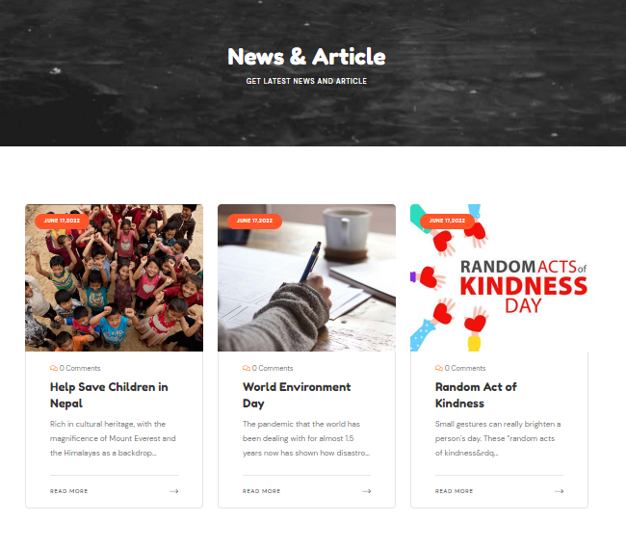

# Services

Company services detail are provided through this management. Provide the detail information while adding the record and save the information. In service section provide the icon class or choose thumb image. This will be shown in listing of services. Listing of services in website is shown below:

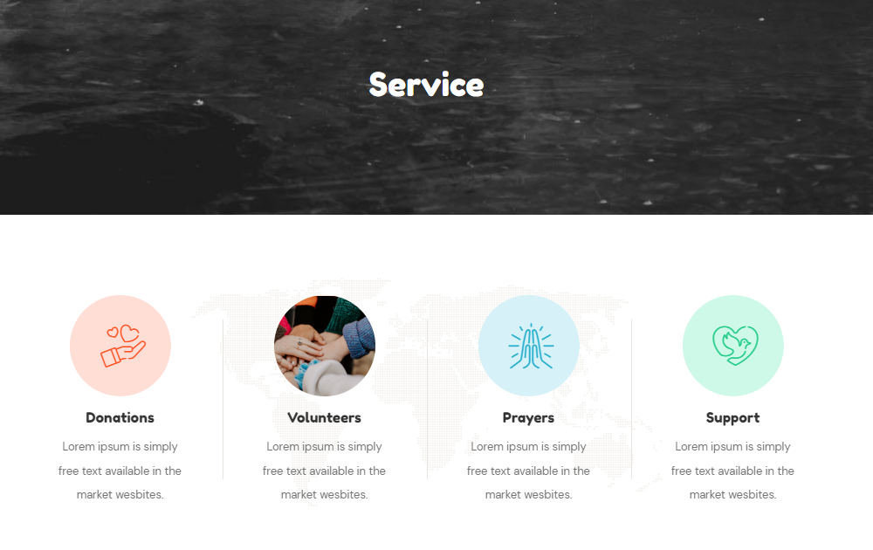

# Programs

Programs are created to collect the donation. All the donation information are provided through this management. Enter the basic information, dates and donation target amount with donated amount. The programs added in this management will be listed in website in program section as shown in picture below:

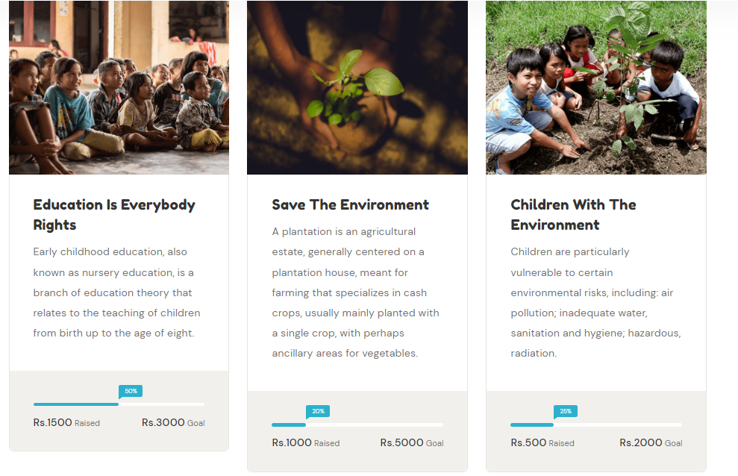

# Events

This management is designed to give information about the different events that is organized by the organization. Provide the detail information in this section so that website user can view the full detail about the events.

# Popup Notice

Popup notice is displayed at the time of website loading. A notice will appear in front of website at first showing some important information to website visitors.

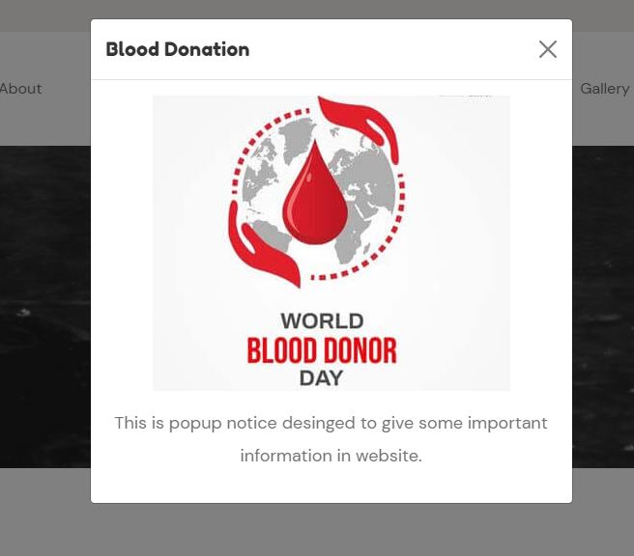

# Team Members/Volunteers /Supporters

This management allows admin user to manage team member and volunteers of the organization. Enter the detail the of team member and volunteers to list it in website.

Interested person can apply to volunteers through website. All the request will be listed in admin panel. Admin user can check the detail information and accept the volunteer request.

Supporter logo will be displayed in website home page.

# Newsletters

Organization may publish or design new programs and its templates. So, these design and templates can be published through website newsletter. Provide the title and upload the file of newsletter. This will be visible to website visitor and can download it.

# Frequently Asked Question

Provide the general question and its answer that general person needs to know about the organization. These FAQs will be published in website as shown in picture below:

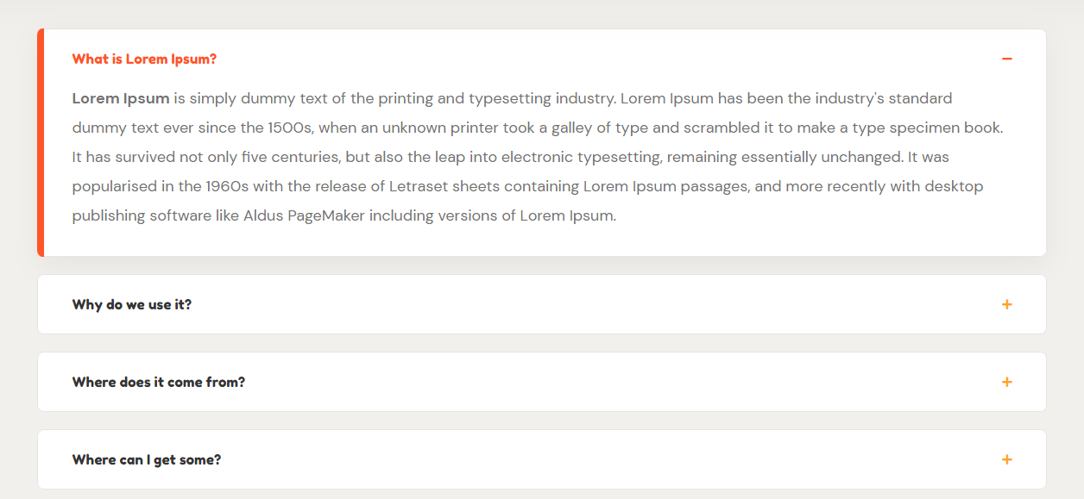

# Site Menu

Allows to manage the main and footer navigation of the website. Admin panel allows to link any content to website through this management.



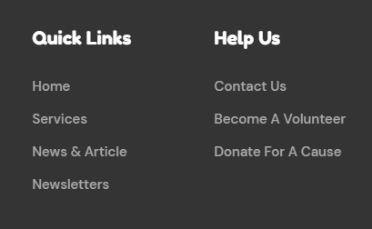

Main Menu

# Footer Menu Media

Media is the management where website related medias like images and document are managed.

* Go to media through admin panel side menu inside CMS
* A media screen will appear as shown in figure below:

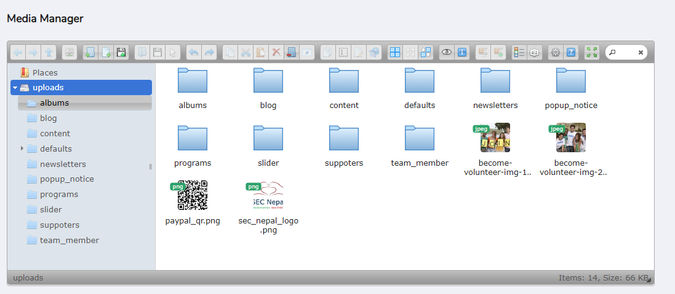

* User can upload the necessary files, remove it.
* User can organize the file in different folder as shown in picture above.

# Reports

Reports section contain the different types of requests received through website.

1. Donner: Received through donation form.
2. Contacts: Received through feedback form of contact us page.
3. Testimonials: Provided by customers through different source and added by admin user to display in website.

# Users and Role

## User Management

Admin panel is not available to all visitor of website. Only authorized user can access this admin panel. Authenticated admin creates other users and their credentials to access the admin panel. Each user will get their respective credentials to access the admin panel.

## Role Management

User credentials is only to get access through admin panel, but user may not get permission to use the available features in admin panel. Each user has its own role and each role has its own permission to use admin panel. So, to give permission to user role please follow the below steps:

1. Go to users and roles from admin panel.
2. Choose Role.
3. User will be redirected to listing page of role management as shown in picture below:

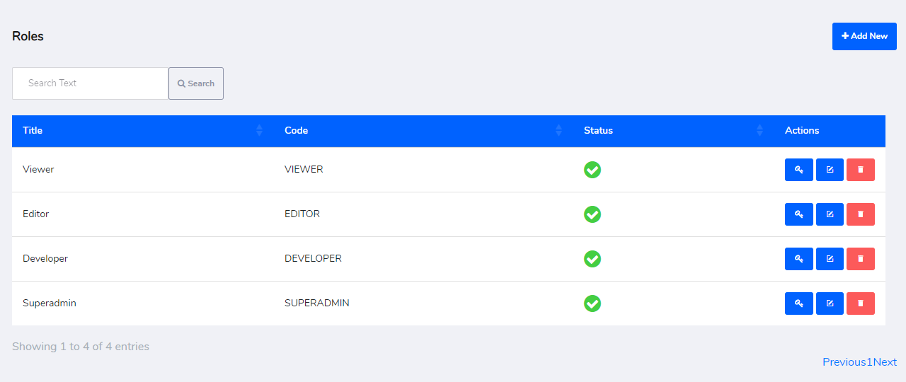

1. Create any new role or use available role.
2. Now click on permission button near to edit button.
3. User will be redirected to Permission page as shown in picture below:

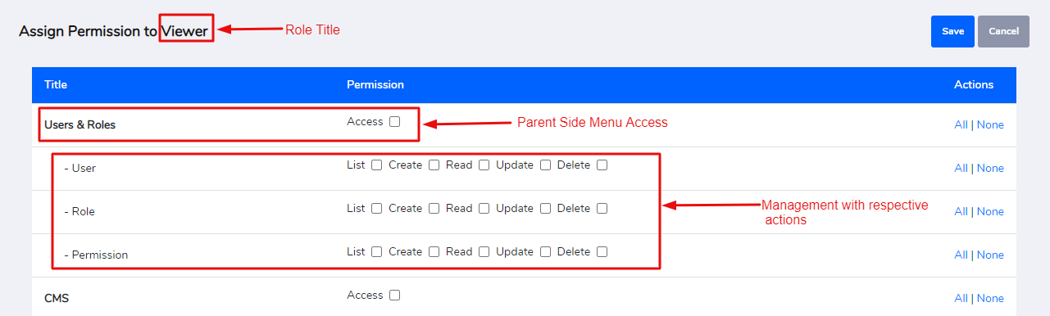

1. Choose the parent menu that needs to be assigned to selected role.
2. Choose the action that needs to be provided to selected role for respective managements.
3. Click on save button.